Our [class/school/district] is Competing in the [Exact Path Contest Name]
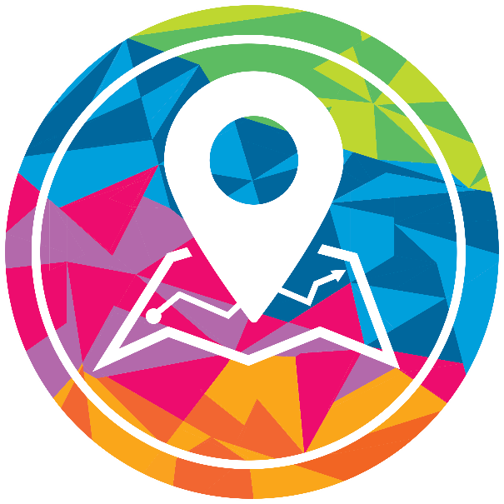
From [start date to end date ex. October 1st – October 31st], we will be competing against [district/school/grade level/class] to become the Exact Path Contest Champion! As a reminder, Edmentum Exact Path is a K-12 personalized math, reading, and language arts program that pinpoints learning needs and provides each student a unique set of lessons and activities to close skill gaps and propel learning forward.
How to WIN!
- Students will be encouraged to work in their Exact Path learning paths to make individual growth and master skills!
- When students complete lessons successfully and earn 80% or above for each skill on their Progress Check (the assessment that follows each set skills) they will earn Trophies!
- Students can track their success by reviewing their Rewards area. Here, they can check in on Trophies earned and Challenges completed.
- Become a winner!
[NOTE NUMBER OF INDIVIDUAL OR SCHOOL WINNERS]: The top [student/class/grade/school] with [note the metric for your contest – ex. The highest number of Mastery Trophies earned] will be awarded [prize details here ex. An Amazon gift card, class pizza party].
[NOTE NUMBER OF INDIVIDUAL OR SCHOOL WINNERS]: The top [student/class/grade/school] with [note the metric for your contest – ex. The highest number of Mastery Trophies earned] will be awarded [prize details here ex. An Amazon gift card, class pizza party].
Questions? Contact your child’s teacher for more information.
Your Student’s Login Information:
Exact Path is accessible from any Internet-enabled device anywhere students are learning
Go to: https://login.edmentum.com/
Account Login: | User Name: | Password:

