Start working in Exact Path to earn great prizes!
From [start date to end date ex. October 1st – October 31st], our [district/school/grade level/class] is competing against [district/school/grade level/class] to become the Exact Path Contest Champion!
- [NOTE NUMBER OF INDIVIDUAL OR SCHOOL WINNERS]: The top [student/class/grade/school] with [note the metric for your contest – ex. The highest number of Mastery Trophies earned] will be awarded [prize details here ex. An Amazon gift card, class pizza party].
- [NOTE NUMBER OF INDIVIDUAL OR SCHOOL WINNERS]: The top [student/class/grade/school] with [note the metric for your contest – ex. The highest number of Mastery Trophies earned] will be awarded [prize details here ex. An Amazon gift card, class pizza party].

How to WIN!
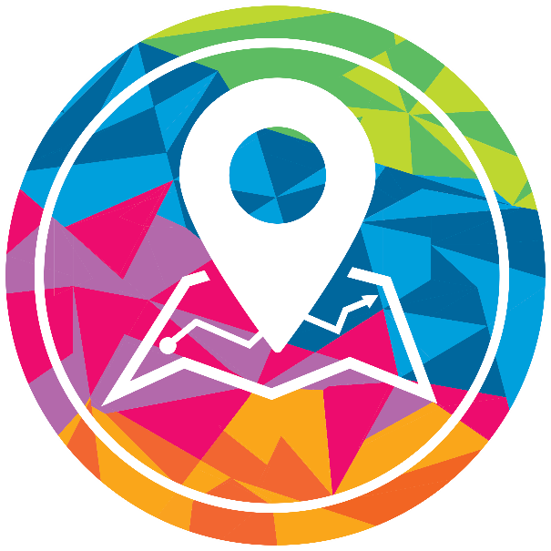
- Make sure all of your students have active learning paths in Exact Path. If they don’t, administer the diagnostic, update data from one of our assessment partners, or auto-generate an on-grade level learning path so all students are eligible to compete.
- Encourage students to complete lessons in their learning path and earn their very best score on their Progress Check, the assessment that follows each set of up to four skills. Progress Check scores are what determine if a skill has been mastered, and students earn a Trophy for each mastered skill that they earn an 80% or above on.
- Encourage students to track their progress by reviewing the Rewards area in their student interface. As an educator, run a Learning Path Progress report for the duration of the contest to check in on individual progress.

Questions? Email [put a contact email here].

